

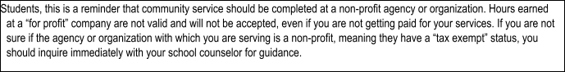

Student Name Grade Advisory/Homeroom

|  |  |  |  |  |  |
| --- | --- | --- | --- | --- | --- |
| **Agency Name** | **Service Activity** | **Hours**  **Earned** | **Date(s) of**  **Activity** | **Supervisor’s**  **Signature** | **Supervisor’s**  **Contact #** |
|  |  |  |  |  |  |
|  |  |  |  |  |  |
|  |  |  |  |  |  |
|  |  |  |  |  |  |
|  |  |  |  |  |  |
|  |  |  |  |  |  |
|  |  |  |  |  |  |
|  |  |  |  |  |  |
|  |  |  |  |  |  |

Briefly describe your specific efforts and experience as a volunteer.

***\*See additional questions on the back\****

**

What skills and/or talents did you acquire through these volunteer experiences?

What do you feel you contributed by volunteering?

Why do you feel it is important to engage in community service opportunities?

**Student Name:**  **Cohort:**  **Date:**

This is to certify that the above-named student has completed the community service requirement as prescribed by the Atlanta Board of Education.

**Counselor’s Signature: _ Date:**

**School:**

**Hours earned Semester 1:**  **Semester 2:**

**Cumulative Hours Total for the Student’s High School Career:**